**FITFLIX: PERSONAL FITNESS COMPANION**

**1.Introduction**

Project Title: Personal Fitness Companion

Team ID: NM2025TMID46920

Team Members: 5

Team Leader: ARCHANA C

Mail id[: archanachennaiyan60@gmail.com](mailto::%20archanachennaiyan60@gmail.com)

|  |  |
| --- | --- |
| **Team members** | **Mail id** |
| Gomathi R | [gomathiperuma2007@gmail.com](mailto:gomathiperuma2007@gmail.com) |
| Gopika A | [gopika2007007@gmail.com](mailto:gopika2007007@gmail.com) |
| Gothawari C | [gothawari99@gmail.com](mailto:gothawari99@gmail.com) |
| Elavarasi D | [elawarasid419@gmail.com](mailto:elawarasid419@gmail.com) |

**2.Project Overview**

* **Purpose**

"Fit Flex Personal Fitness Companion" refers to the Fit Flex. The project aims to companion offers personalized workout plans, detailed fitness and nutrition tracking with meal logging and scanning, and mental wellness tools like guided meditation and sleep sessions, helping users achieve goals such as weight loss, muscle gain, and overall well-being.

* **Features**
  + - Personalized Workouts
    - Fitness Tracking
    - AI-Powered Nutrition Tools
    - Holistic Wellness
    - Progress Monitoring
    - Comprehensive Solution

**3.Architecture**

FRONTEND: React.js with Bootstrap and Material UI

BACKEND: Node.js and Express.js managing server logic and API end points

DATA BASE: MongoDB stores user data, project information, applications and chat messages

* **Component structure**
* HEADER (Navigation)
* Exercise list (Display workout picture)
* Work out details (Shows full workout steps and gym equipment)
* Search/Filter bar
* Favourite section
* Voice Assistant Component
* **State management**
  + - Redux: A popular state management library for react apps, suitable for managing complex state logic.
    - MobX: A reactive state management library that simplifies state management.
    - Context API: A built-in reacts API for state management, suitable for smaller apps or specific features.
* **Routes**
  + - Home/dashboard
    - Workouts
    - Workout detail
    - Progress
    - Goals
    - Profile

**4.SETUP INSTRUCTIONS**

* **Prerequisites**
  + - Node.js
    - MongoDB
    - Git
    - React.js
    - Express.js-mongoose-Visual Studio Code
* **Installation**
  + - Git clone [repository link]
    - Cd personal fitness-virtual-assistant
    - npm install
    - npm start

**5.Folder structure**

SB-works/

|--client/ # React frontend

| __components/

L__pages/

|__server/ #Node.js backend

|__routes/

|__models/

|__controllers/

* Client: React frontend
  + Components: Reusable UI components
  + Pages: App pages/routes
* Server: Node.js backend
* Routes: API routes for the backend

**6.Running the Applications**

* FRONTEND
  + - npm start
    - Runs the app in development mode at <https://localhost:3000/>

**7.API Documentation**

* USER
* /api/user/register
* /api/user/login
* PROJECTS
* /api/projects/create
* /api/projects/:id
* APPLICATIONS

/api/apply

* CHATS
* /api/chat/send
* /api/chat/: userId

**8.User Interface**

* Screenshots or GIF’s of:
  + - Home page with search bar
    - Workout list grid
    - Detailed workout view
    - Favourites page

**9.Styling**

* + CSS Frameworks/Libraries: Tailwind
  + CSS or Styled-Components
  + Theming: Light/dark mode toggle for better UX

**10.Testing**

* + Testing Strategy
  + Unit testing with Jest
  + Component testing with React Testing library
  + Code Coverage

Make sure key features like workout tracking, goal setting and progress analytics are thoroughly tested.

**11.Screenshots or Demo**

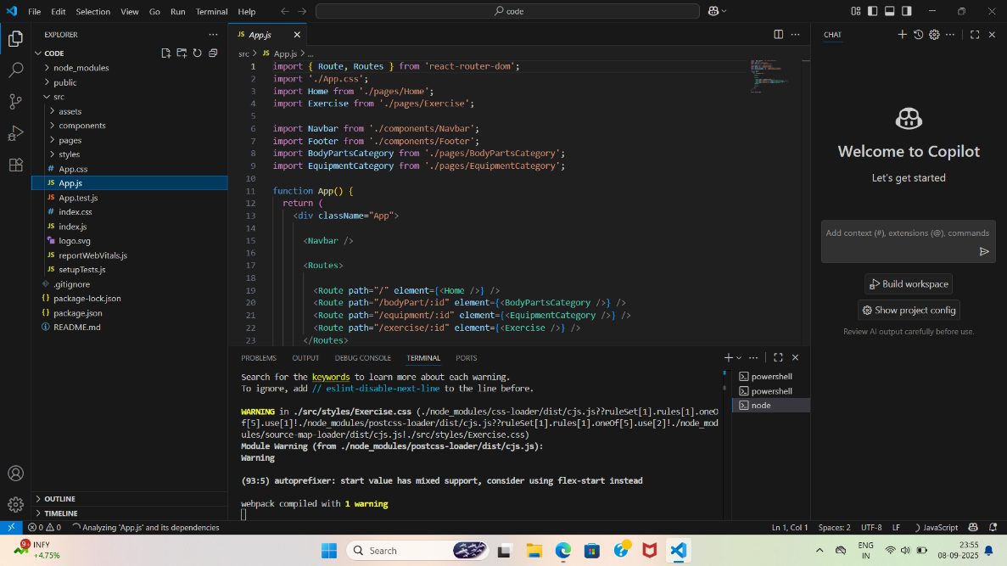

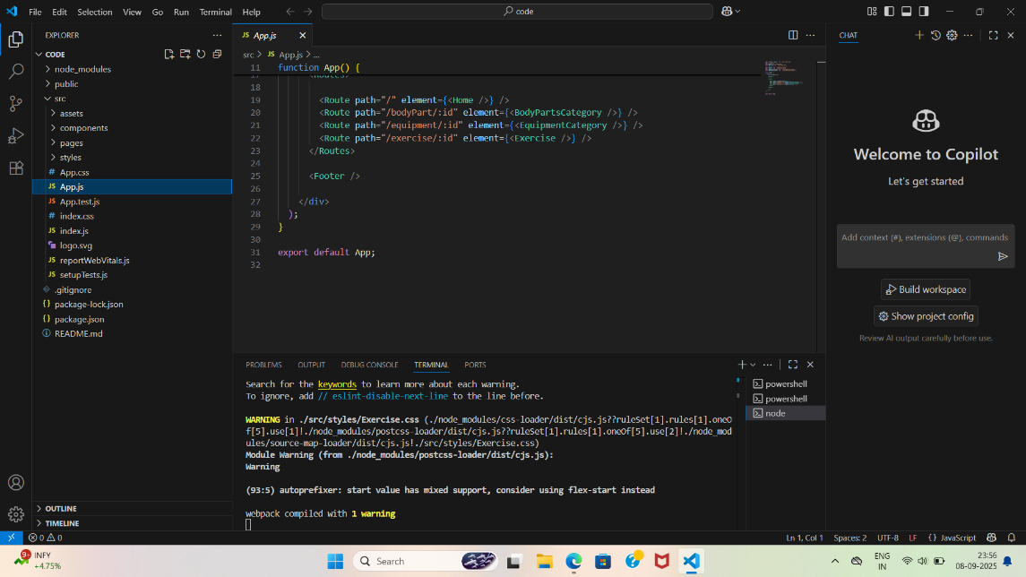

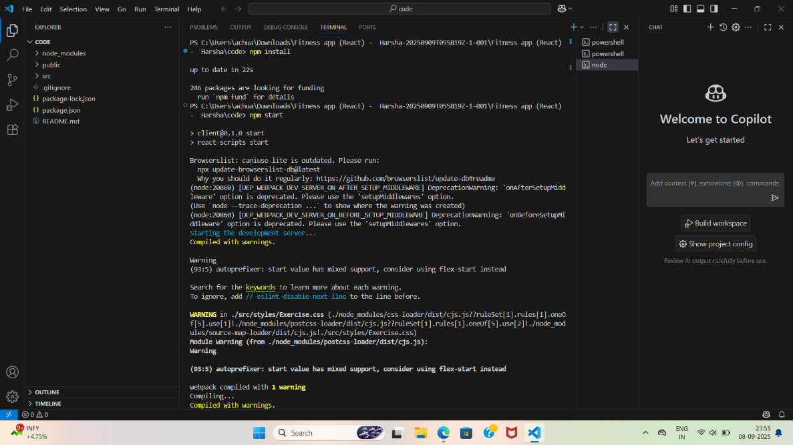

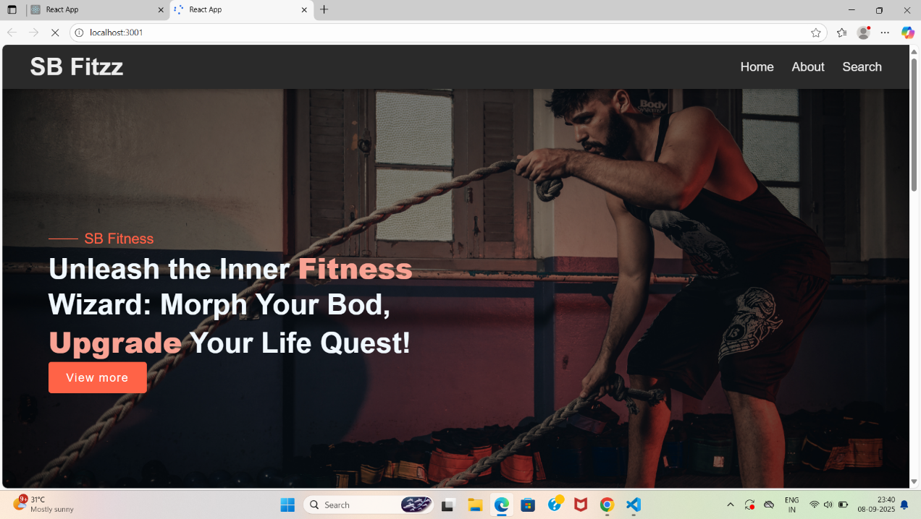



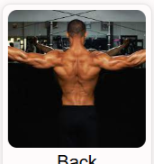





**["C:\Users\achua\Downloads\VID-20250915-WA0012.mp4"](../Downloads/VID-20250915-WA0012.mp4)**

**12.Known issues**

Voice assistant may not support all languages initially.

**13.Future Enhancement**

* + - Add grocery list generator
    - Support multiple languages and regional cuisines
    - AI-based meal planner